**Project I Shortest distance searching**

**Problem:**

A polynomial surface $S(u,v)$ is defined as the following equation,

$$\left\{\begin{aligned}x=5u, \\ y=5v, \\ z=-0.38+\frac{25}{3}u+\frac{4}{3}v-\frac{25}{3}u^{2}-\frac{10}{3}uv\end{aligned}\right.$$

where $u,v∈[0,1]$. Now if a query curve $Q(t)$ is specified, please use the gradient method to find the shortest distance between $Q(t)$ and $S(u,v)$**.**

(a). $Q_{1}\left(t\right)=\left[5t,5t,\frac{25}{6}t^{2}-\frac{25}{6}t+5\right], t∈\left[0,1\right]$

(b). $Q_{2}\left(t\right)=\left[5t,5t,53{.976t}^{4}-104.64t^{3}+{64.256t}^{2}-12.589t+5\right], t∈\left[0,1\right]$

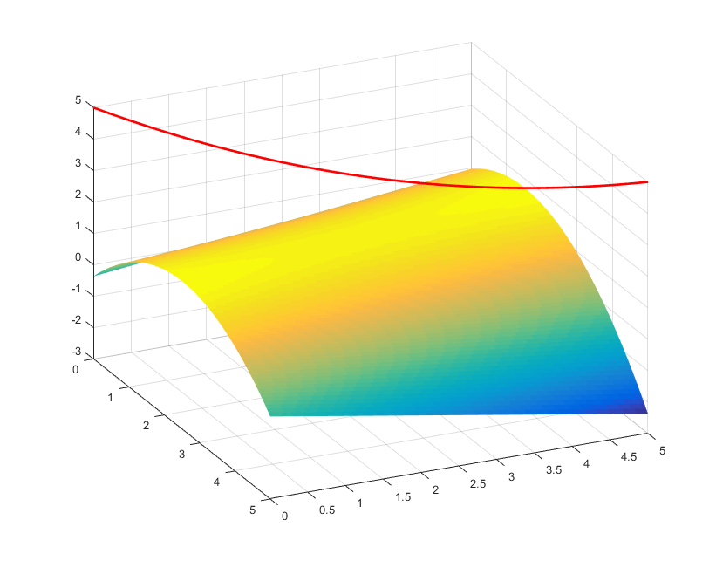

Figure 1

**Requirement:**

1. Develop a MATLAB function based on the gradient method in order to find the shortest distance between $Q(t)$ and $S(u,v)$, and the corresponding points on $Q(t)$ and $S(u,v)$.
2. Find the shortest distance for both two query curves $Q_{1}\left(t\right)$ and $Q_{2}\left(t\right)$. Display the shortest path on the plot with the query curve and the surface (e.g. Figure1)

**Submission:**

Please submit a report fulfilled all of requirements includes the results for both queries, as well as the relative m files. The due of this project is 11/27/2017.